Week 9: Pipeline Creation using script
- Evaluation of Jenkins pipeline.
- WORKING ON BUILD TRIGGERS FOR LAST JENKINS PIPILINE
- Hands-on practice on creation of scripted Jenkins pipeline.
- Take the screenshots for above task

Procedure
General :
Description :- provide the description of the project
Build triggers: here we can provide with build triggers of you choice
Advance project option:
Definition:
Choose pipeline script

Here code for pipeline -script

Copy the code there
-------------------------------------------------------------------------------------------------------------------------
pipeline {
agent any
tools{
maven 'MAVEN-HOME'
}
stages {
stage('git repo & clean') {
steps {
//bat "rmdir /s /q mavenjava"
bat "git clone provide your github link"
bat "mvn clean -f mavenjava"
}
}
stage('install') {
steps {
bat "mvn install -f mavenjava" #project name#
}
}
stage('test') {
steps {
bat "mvn test -f mavenjava"
}
}
stage('package') {
steps {
bat "mvn package -f mavenjava"
}
}
}
}
Apply and save
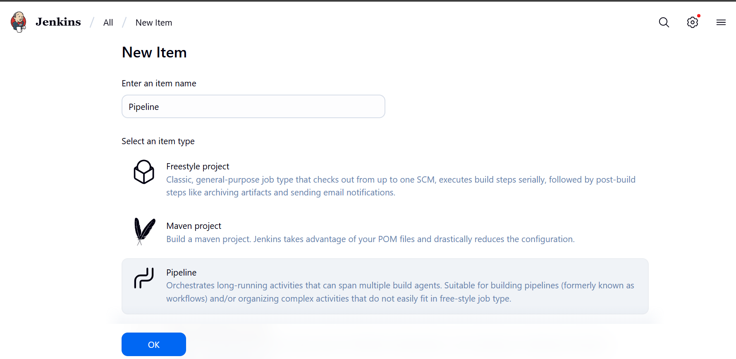
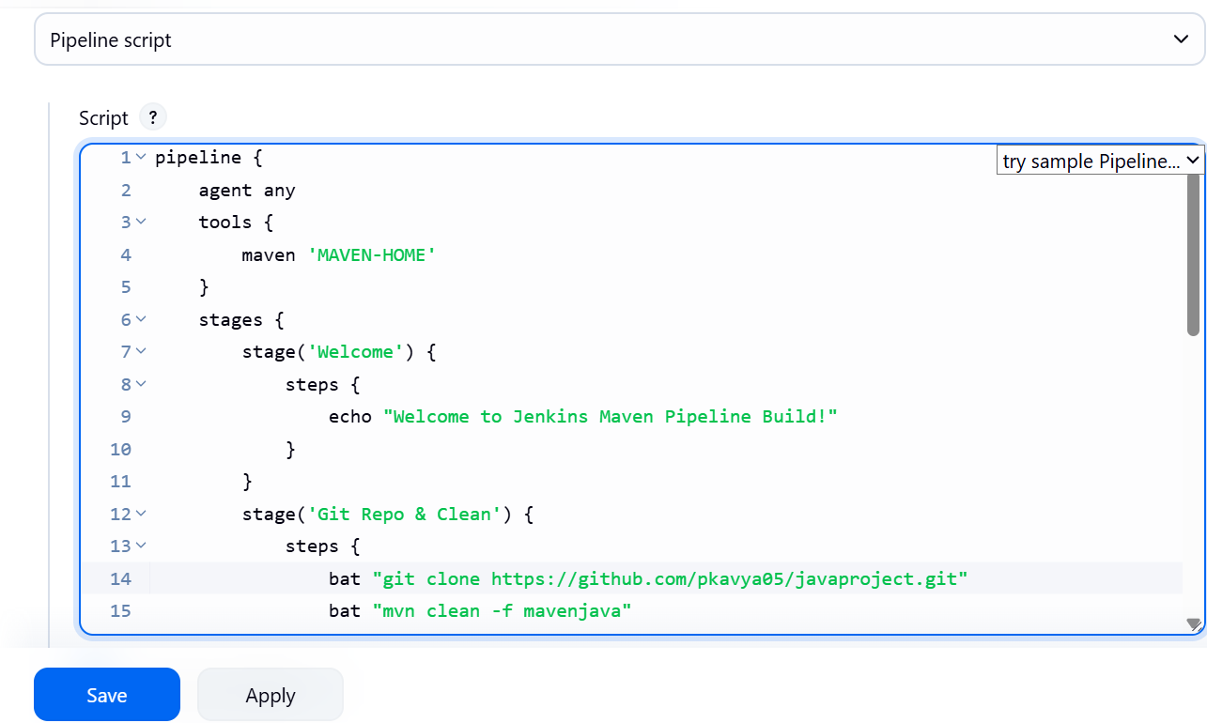
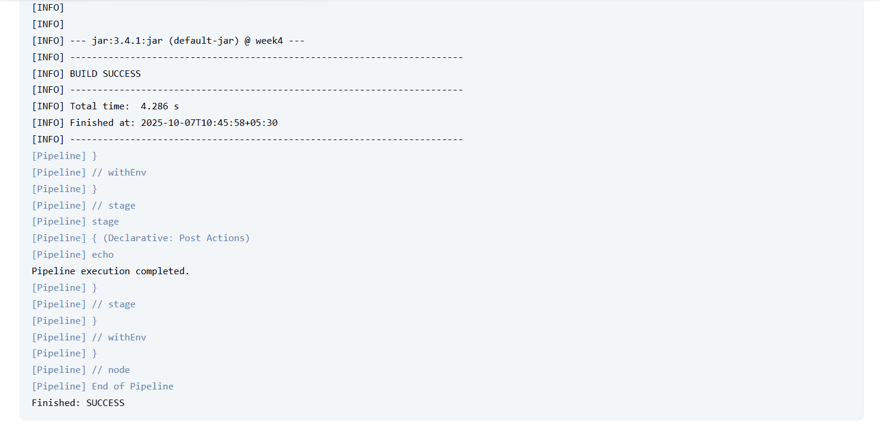
SBQ’s:
- Your manager asks you to clean the workspace before building — which stage in this pipeline takes care of it?
Git Repo & Clean

- The GitHub repository link is missing in the script — where exactly do you provide it?
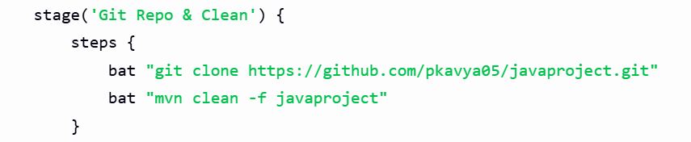

- If Maven is not configured globally in Jenkins, which section of the pipeline will fail first?
The pipeline fails at the first Maven command, i.e.,
mvn clean inside Git Repo & Clean stage — because the tool path (MAVEN-HOME) is not found.

- A teammate complains the pipeline is not creating .war files — which stage is responsible?
The Package stage — it runs mvn package, which generates .jar or .war.

- Your test cases failed, but the pipeline still continued — how will Jenkins behave in the test stage?
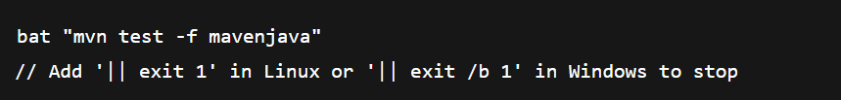

- Instead of running nightly builds, you want this pipeline to trigger only when GitHub changes occur — where will you configure it?
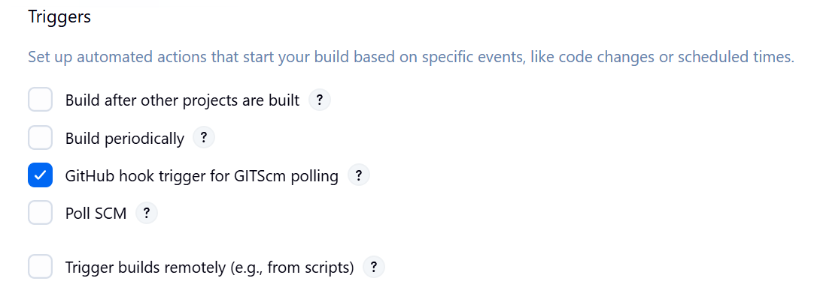

- If you replace mvn clean with mvn compile, what difference will it make to the project build?
mvn clean deletes old compiled code.
mvn compile just compiles code without cleaning old outputs — may cause conflicts.
- The project folder name is not mavenjava but studentapp — which parts of the script must you edit?
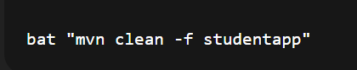

- If the install stage fails, will the test and package stages still run in this pipeline?
No. Jenkins stops execution when a stage fails.

- A student asks where to add deployment steps to Tomcat after packaging — which is the best place in this script?
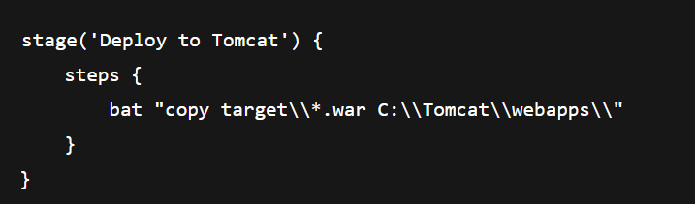
- Why is tools { maven 'MAVEN-HOME' } used in this pipeline?
It tells Jenkins to use the globally configured Maven installation

- If GitHub credentials are private, how can you secure them in the git repo & clean stage?

- Which Jenkins plugin is needed to recognize the pipeline { ... } structure in this script?
Pipeline Plugin
- In Windows, the script uses bat commands — what change would you make if Jenkins runs on Linux?
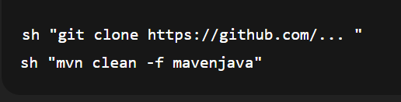
- How will you modify the pipeline to stop execution if the GitHub clone command fails?
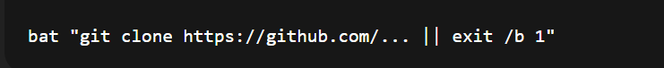
Your project lead asks you to print a welcome message in Jenkins to confirm the pipeline is working — how would you script it?
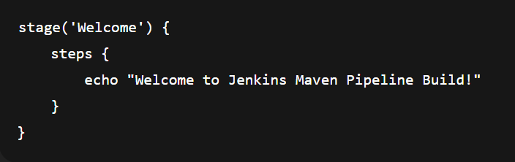

- A teammate forgot to pull the latest GitHub code before building; how can you fix this in your pipeline?
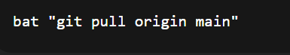
- Your Java file Hello.java must be compiled every time code is committed — how will you add this step?
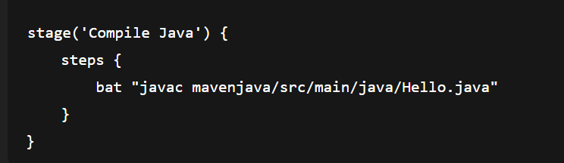
- Tests should stop the pipeline if they fail — where will you put the mvn test command?
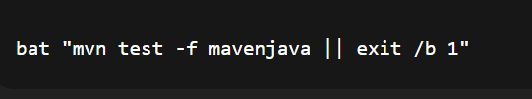

- Every evening at 6 PM your pipeline should run automatically — how can you set this in Jenkins?
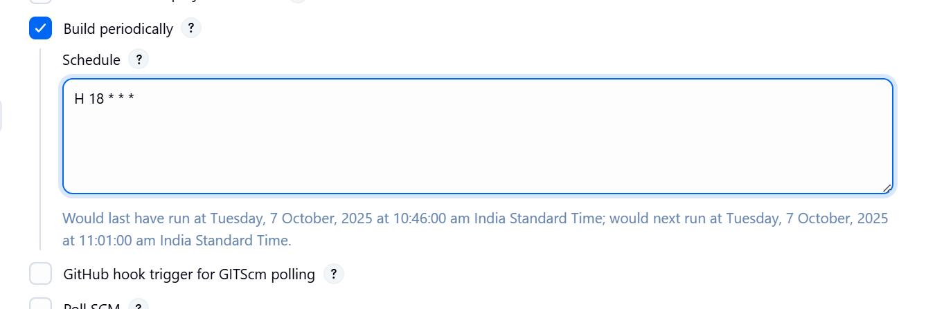

- You only want to package the project if compilation succeeds — how would you connect the stages?
Place stages sequentially (which is already the default). Jenkins won’t run next if previous fails.
- Your professor wants a .jar file generated for submission — what pipeline stage will you add?
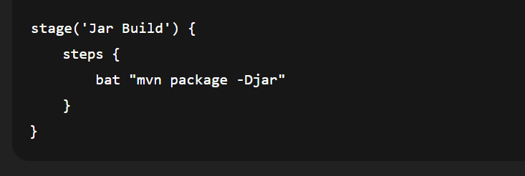
- A Git clone step is failing due to wrong credentials — how would you secure and use them in your script?
- A teammate wants to see the build number inside console logs — how do you print it in the pipeline?

